blinkit Grocery Data Excel Project
Project Overview
This project uses the blinkit Grocery Dataset to perform detailed sales and performance analytics across multiple outlets.
The goal is to extract actionable insights into product performance, outlet efficiency, and sales distribution using advanced Excel-based analysis and dashboarding.
Through data cleaning, transformation, and visualization, this project builds a structured foundation for understanding how blinkit’s grocery operations perform across various item categories, outlet types, and geographic tiers.

Dataset Description
It captures item-level sales information across multiple store formats and includes product, outlet, and rating details.:
- Sr No: Unique ID for each entry
- Item Identifier: Code for each grocery product
- Item Type: Product category (e.g., Dairy, Snacks, Beverages)
- Item Fat Content: Regular or Low Fat classification
- Item Weight: Average product weight (kg)
- Item Visibility: Shelf display ratio in store
- Sales: Total revenue (₹) per item
- Rating: Customer satisfaction score (1–5)
- Outlet Identifier: Store code
- Outlet Establishment Year: Year outlet was opened
- Outlet Type: Store classification (Supermarket / Grocery)
- Outlet Size: Store size (Small / Medium / High)
- Outlet Location Type: City tier (Tier 1 / 2 / 3)

Business Objectives
The primary goal of this analysis is to evaluate blinkit’s retail performance across products, stores, and locations to support data-driven business decisions.
Specific objectives include:
- Analyse sales and product performance across different item categories and fat contents.
- Evaluate outlet performance based on type, size, and location.
- Understand the relationship between item visibility, weight, and sales.
- Identify key trends in customer ratings and product demand.
- Create an interactive Excel dashboard for management to visualize KPIs and regional performance in real time.

Key Business Questions
1. Sales and Performance Analysis
- What is the total sales performance across all outlets and how does the average sales per item vary by category?
- How do different outlet sizes (High, Medium, Small) impact total revenue?
- Which outlet establishment years show the strongest growth and peak sales performance?
- Are sales distributed evenly across outlet types (Supermarket vs. Grocery Store)?
2. Product & Category Insights
- Which item types (e.g., Fruits & Vegetables, Snack Foods, Household, Dairy) contribute most to overall sales?
- Which low-selling categories need promotional strategies (e.g., Seafood, Breakfast, Starchy Foods)?
- How does fat content (Regular vs. Low Fat) influence overall sales distribution?
- Which product segments have the highest opportunity for improvement in visibility-to-sales ratio?
3. Outlet & Regional Performance
- Which outlet locations (Tier 1, 2, 3) drive the most sales volume?
- How does outlet type (Supermarket Type1, Type2, Type3, Grocery Store) affect total and average sales?
- Are Tier 3 outlets generating higher total sales due to larger customer bases or broader product availability?
4. Customer Experience & Rating Trends
- What is the average customer rating across outlets, and how does it relate to total sales performance?
- Do higher sales correspond to higher customer ratings, or are there outlets with sales–rating imbalance?
- How can BlinkIT leverage high-rated but low-selling items to boost visibility and profits?

Tools & Techniques
- Microsoft Excel
- Power Query for data cleaning and standardization
- Pivot Tables for summarizing item- and outlet-level insights
- Pivot Charts and Dynamic Slicers for visualization
- Conditional Formatting to highlight top and low performers

Deliverables
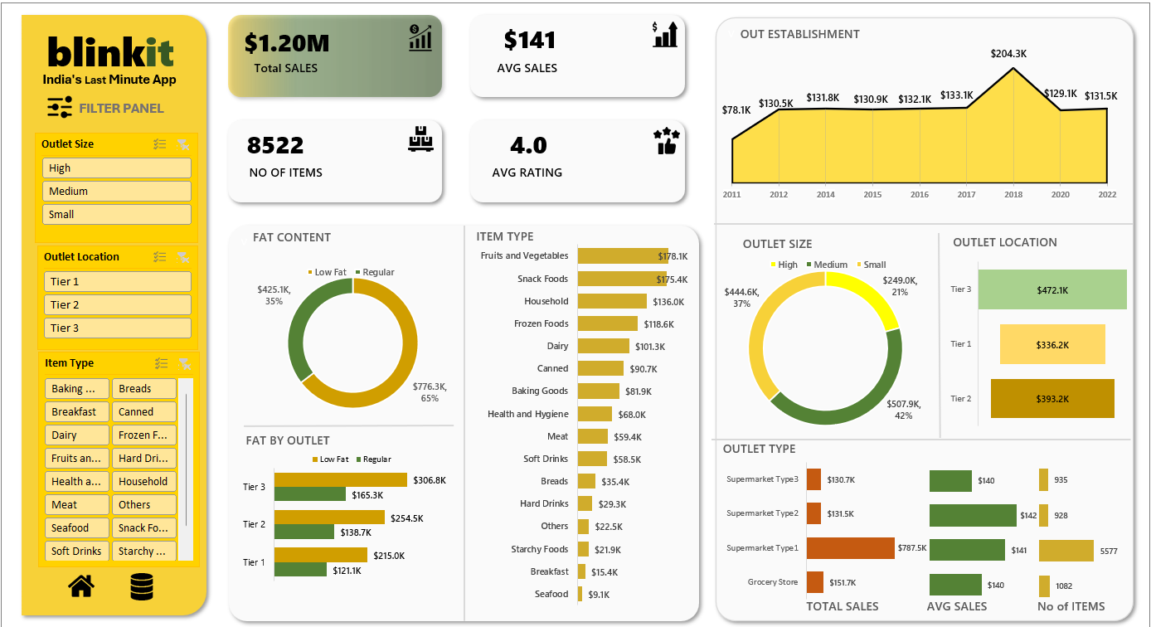

Insights:
- Total Sales: ₹1.20M | Avg Sales: ₹141 | Items: 8,522 | Avg Rating: 4.0
- Top Outlets: Supermarket Type1 & Type2
- Outlet Size Impact: High & Medium outlets generate over 75% of total revenue.
- Top Categories: Fruits & Vegetables (₹178K), Snack Foods (₹175K), Household (₹136K)
- Low Performers: Seafood, Breakfast, Starchy Foods (<₹25K)
- Fat Content: Regular (65%) outsells Low Fat (35%).
- Best Location: Tier 3 – ₹472K total sales
- By Size: Medium (₹507.9K) > High (₹444.6K) > Small (₹249K)
- Peak Year: 2018 – ₹204.3K in sales
- Avg Rating: 4.0 (High satisfaction)
- Top-rated Items: Fruits & Vegetables, Dairy, Household
- Type1 Supermarkets show strong sales–rating balance

Future Enhancements
- Add Temporal Sales Tracking: Include date fields to analyze monthly and yearly trends.
- Integrate Profit or Cost Columns: To assess margin-based performance, not just sales volume.
- Customer Demographic Data: Adding gender, age, and region details can improve market segmentation.
- Real-Time Data Integration: Use Power BI or Excel Power Pivot connections to automatically refresh dashboards from a live database.
- Predictive Analysis: Apply Excel’s Forecast functions or connect with Python for sales forecasting models.

Conclusion:
The blinkit’s Grocery Excel Project provides a comprehensive analysis of grocery sales performance across products, outlets, and regions.
By leveraging Excel tools like Pivot Tables, Charts, and Power Query, the dataset transforms raw transaction data into valuable insights.
This analysis helps Blin blinkit’s:
- Identify best-selling products and locations,
- Understand customer preferences and outlet efficiency, and
- Take strategic actions to boost future sales and operational performance.

